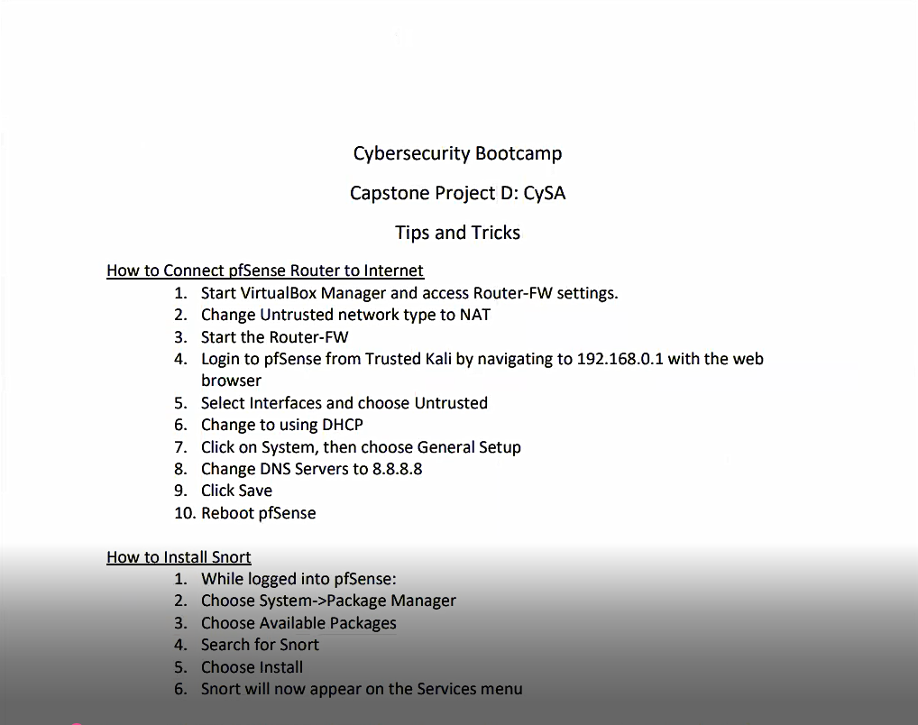

Go to untrusted interface access router-FW settings change to NAT interface,

LOGIN to server pfsense from trusted KALI

SELECT INTERFACES,

CHOOSE UNTRUSTED

CHANGE IT TO USE DHCP INSTEAD, this whole time it’s been statically assigned.

Change out DNS to PUBLIC DNS so googles 8888

Save it, restart it

The untrusted interface will be connected to the internet.

We’re going to install the snort so while logged on pfsense, we’re going to go down to our package manager, CHOOSE available packages, search for SNORT, install it!

IT mentions that snort will now appear in the services menu

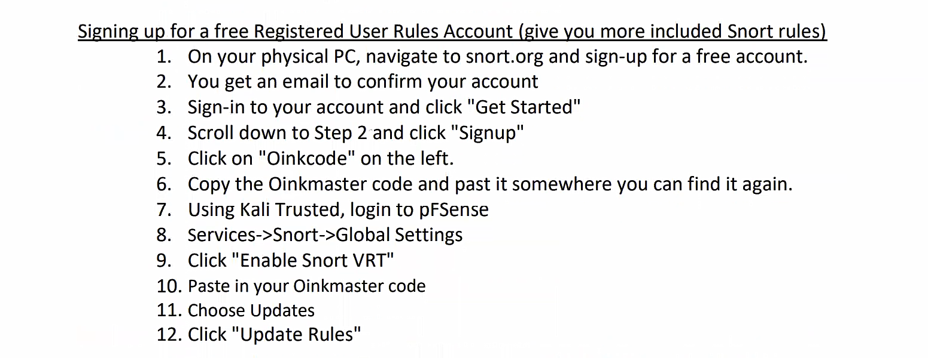



We’re going to sign up for a free account with SNORT, it will give us a CODE that will identify us to SNORT, as being able to receive a SPECIFIC FEED, in this case it’s going to be a free version.

Then once it’s downloaded, we can start to run exploits to TRIGGER an ALARM.

Make sure it’s in IDS.

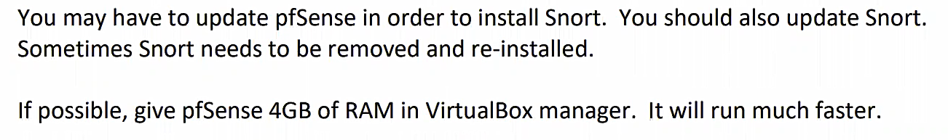

START ROUTER-FW

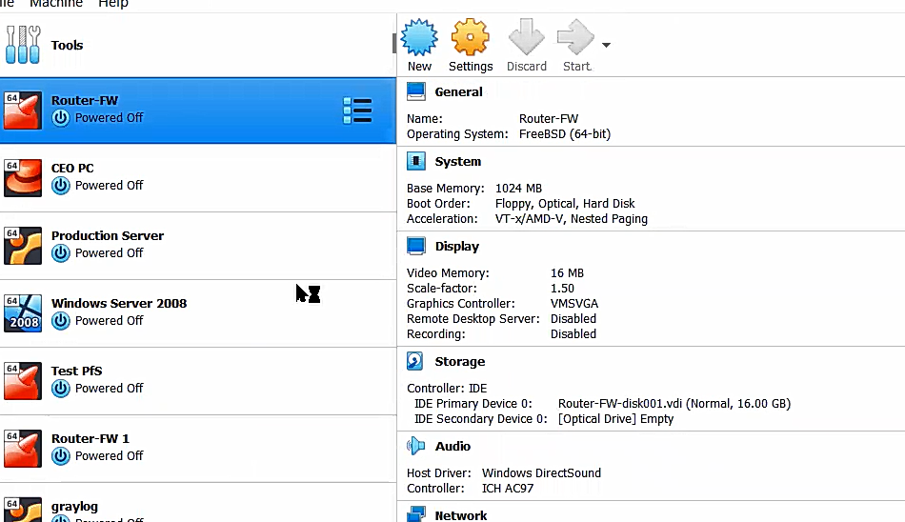

THEN TRUSTED-KALI

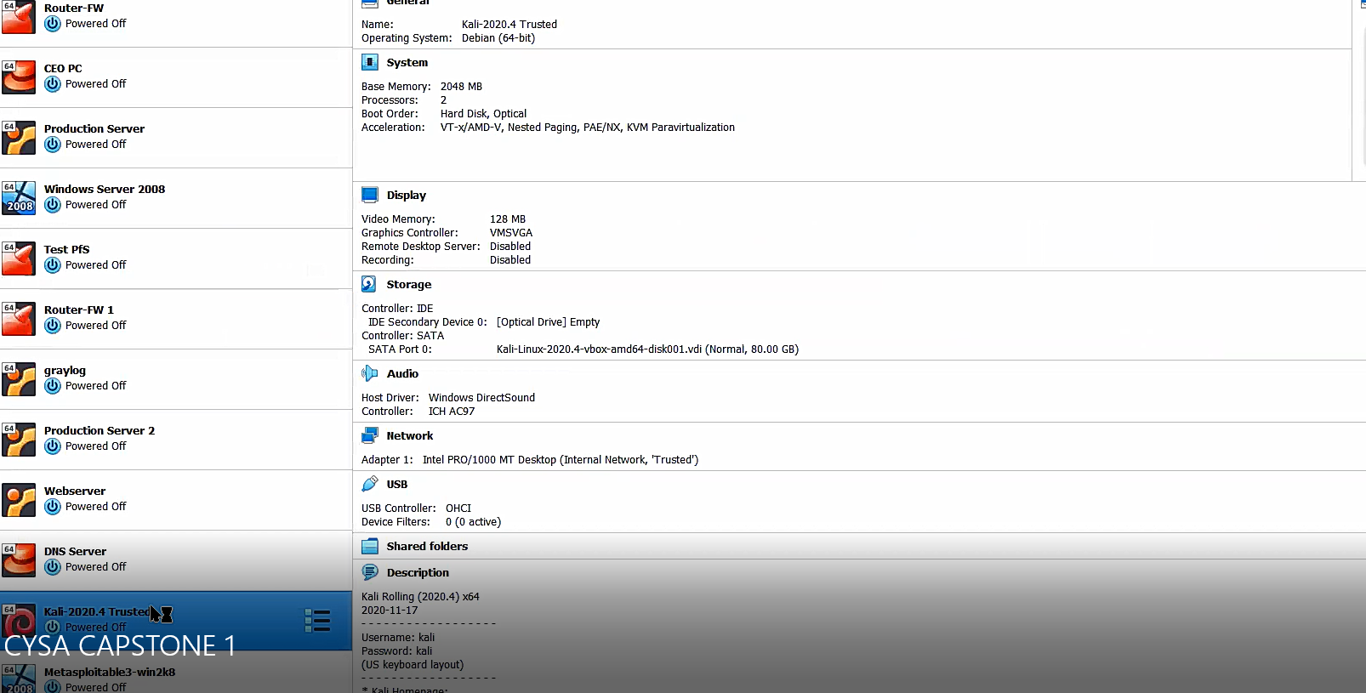

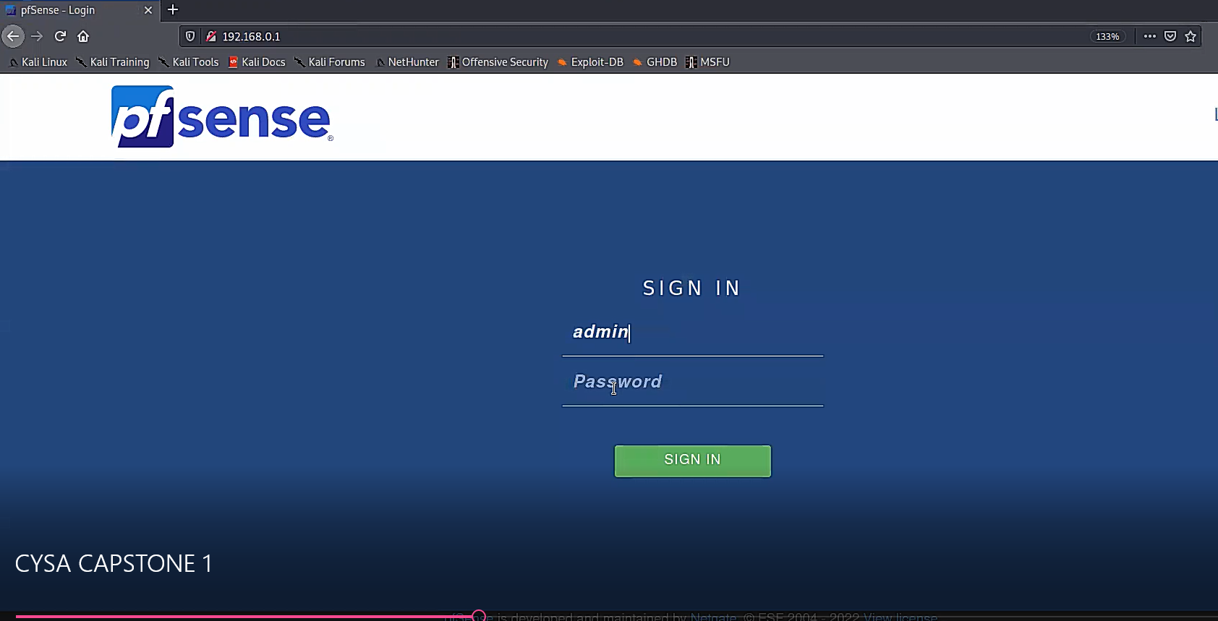

Log into pfSense server firewall

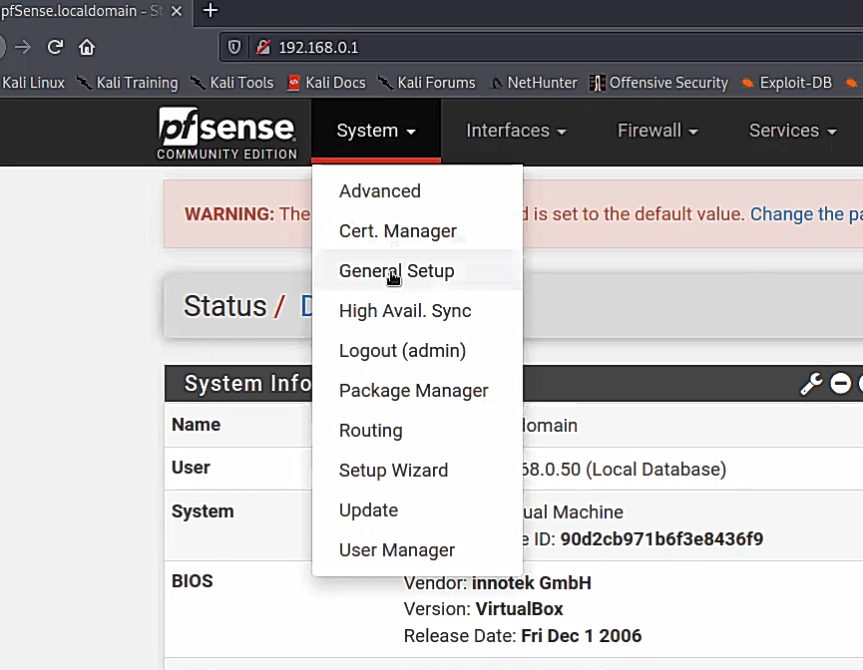

UNDER GENERAL SETTINGS SET TO .11 (MINES MIGHT BE 12)

THEN SET DNS TO GOOGLES DNS 8.8.8.8 AND SAVE

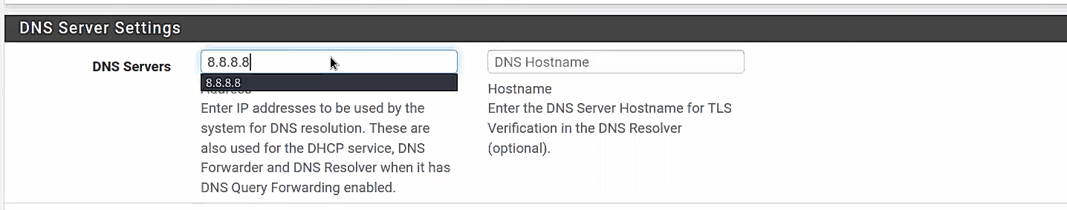

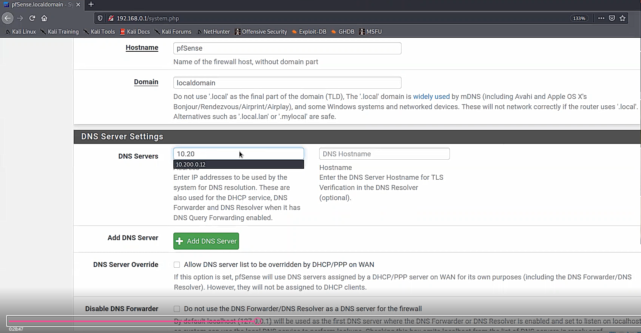

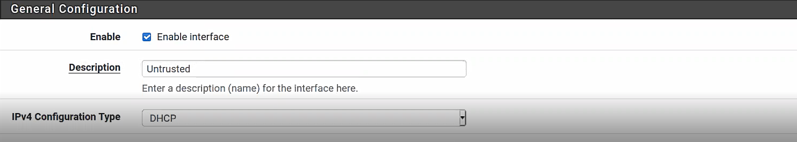

GO TO INTERFACE CHANGE IPV4 FROM STATIC IPV4 TO DHCP SAVE AND APPLY CHANGES.

BUT REMEMBER THE ORIGINAL IP ADDRESS’ TO CHANGE BACK TO LATER

UNTRUSTED: 172.30.0.1/24

TRUSTED: 192.168.0.1/24

DMZ: 10.200.0.9/29

AFTER CHANGES IS SAVED AND APPLIED SIGN OUT AND CLOSE BROWSER

GO INTO ROUTER-FW NETWORK SETTINGS AND ON ADAPTER3 PUT UNDER NAT

ONCE THAT’S DONE CHECK THE CHANGES TO ROUTER-FW AND UNTRUSTED IP ADDRESS:

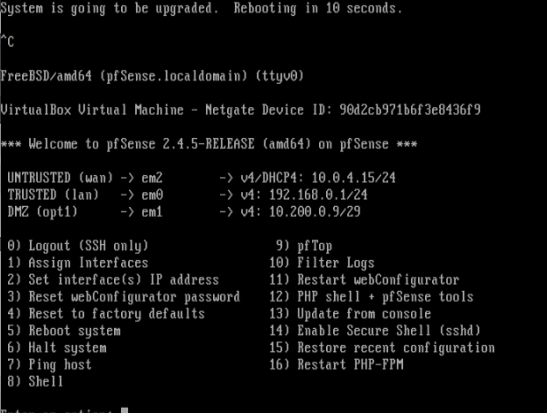

ONCE changes are done log back into pfsense and update under system/update to latest version:

2.52

Once update is done DOWNLOAD SNORT under SYSTEM/PACKAGE MANAGER. SEE BELOW.

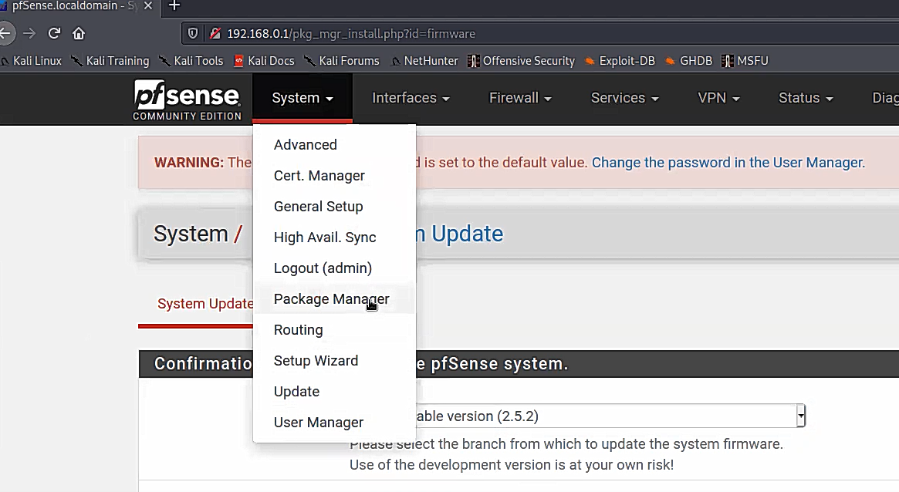hos

THEN UNDER AVAILABLE PACKAGES UNDER SEARCH, TYPE SNORT AND DOWNLOAD PACKAGE.

After downloading under services you’ll have SNORT available to you.

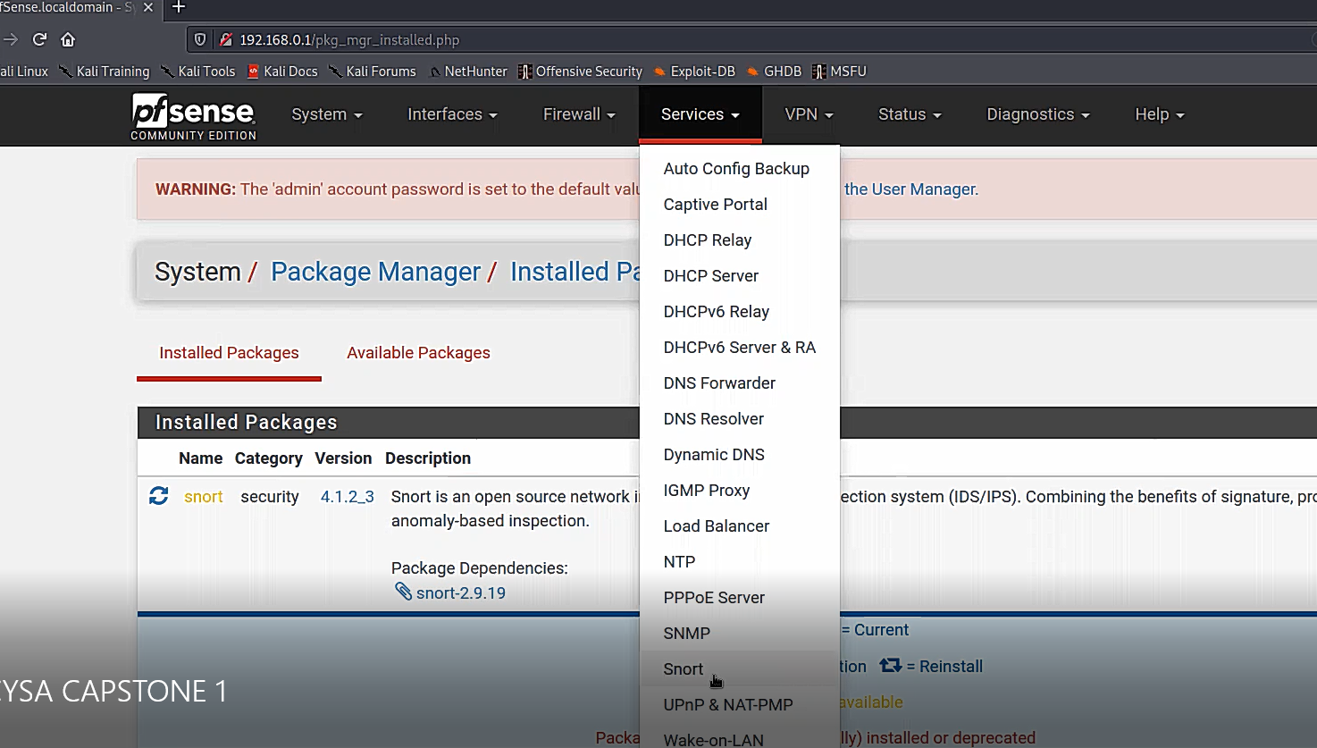

Then you’ll see no interfaces set up yet, so we have to go grab a feed for our ruleset from SNORT.ORG

Note: look at all the other packages example: NMAP!

NOW SECOND SET OF INSTRUCTIONS:



SNORT.ORG OINKCODE:

4a079f86834abcc773397d70e24f72679420c4b9

Mbare23@gmail.com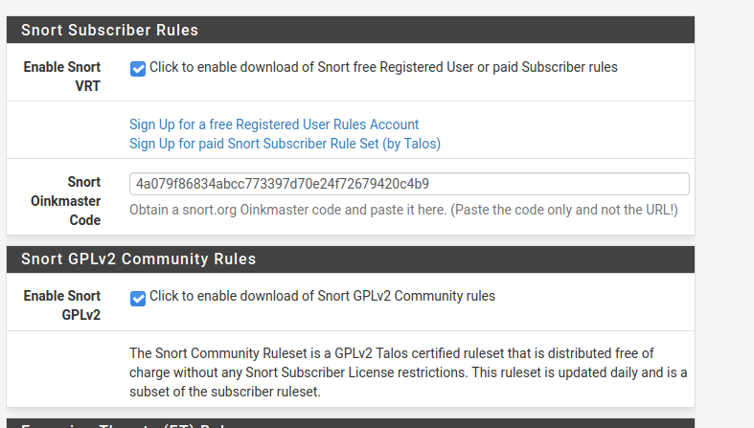

UDATE GLOBAL SETTINGS TO DOWNLOADS RULES AND CLICK UPDATES THEN UPDATE RULES AND THE RULE SETS YOU DOWNLOADED WILL SHOW HERE:

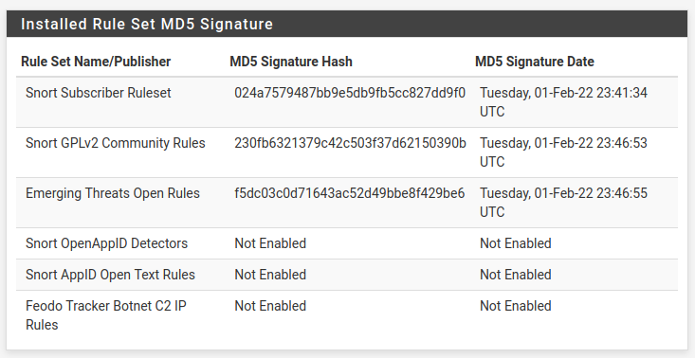

Might want to use this on presentation!!!

NOW CHANGE THE IPV4 SET UP BACK TO GET OFF THE INTERNET TO UPDATE THE FEED:

Go-to SYSTEM/General setup

GO TO DNS AND CHANGE THE GOOGLE IP TO 10.200.0.12 (From last known place)

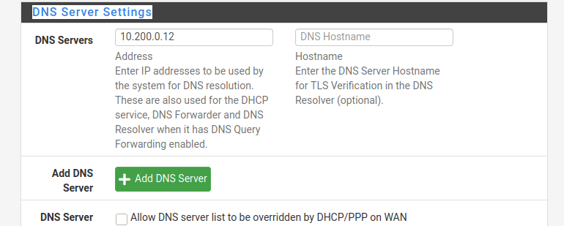

JUST REMEMBER THE IP INTERFACES ORIGINAL ADDRESSES BECAUSE YOU’LL GO BACK AND CHANGE IT BACK TO STATIC as below:

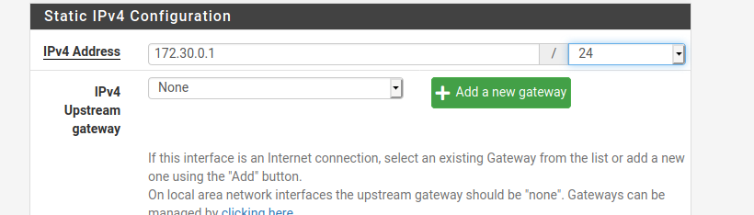

Hit save and apply changes then log out and jump down to

ROUTER-FW and shutdown -h or 6 to halt system. You may have to clt-C to see the updates of the pr.0evious ipv4 address.

Go back to network settings adapter3 and go back to internal for untrusted network.

Log back in to pfsense and go to services/snort to update some custom rules

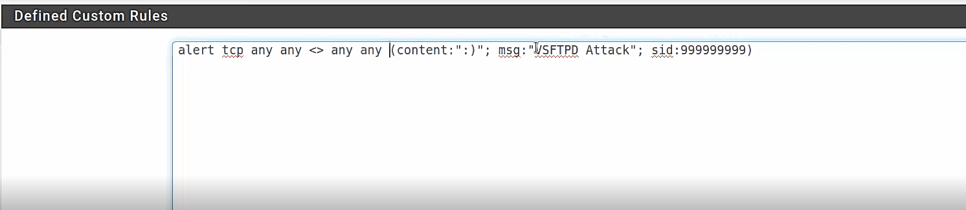

Also had to add manually interfaces to snort overview and update rule settings to IPC policy under security.

Cohost CYSA2

Custom rulesets under trusted rules in snort interfaces

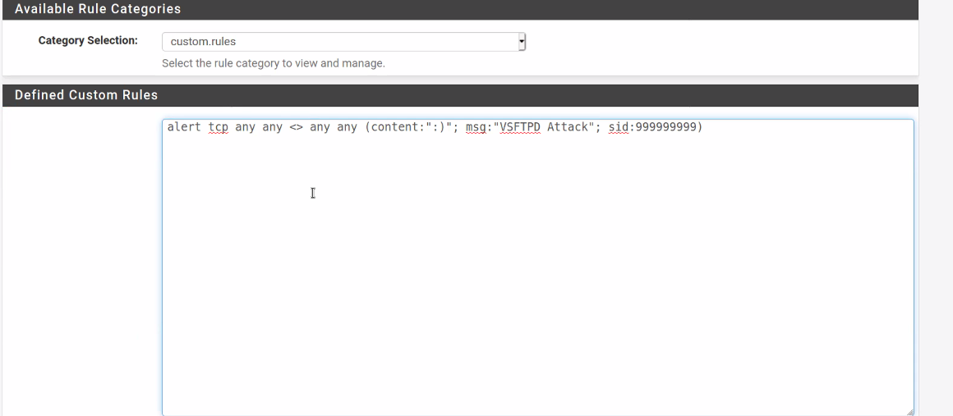

Other rule sets eldon

|  |
| --- |
| alert udp any any -> any 69 (msg:"TFTP GET filename overflow attempt"; content:"|00 01|"; depth:2; isdataat:100,relative; content:!"|00|"; within:100; reference:bugtraq,5328; reference:cve,2002-0813; classtype:attempted-admin; sid:1941; rev:9;) |
|  | alert udp any any -> any 69 (msg:"TFTP PUT filename overflow attempt"; content:"|00 02|"; depth:2; isdataat:100,relative; content:!"|00|"; within:100; reference:bugtraq,7819; reference:bugtraq,8505; reference:cve,2003-0380; classtype:attempted-admin; sid:2337; rev:8;) |
|  | alert udp any any -> any 69 (msg:"TFTP GET Admin.dll"; content:"|00 01|"; depth:2; content:"admin.dll"; offset:2; nocase; reference:url,www.cert.org/advisories/CA-2001-26.html; classtype:successful-admin; sid:1289; rev:4;) |
|  | alert udp any any -> any 69 (msg:"TFTP GET nc.exe"; content:"|00 01|"; depth:2; content:"nc.exe"; offset:2; nocase; classtype:successful-admin; sid:1441; rev:4;) |
|  | alert udp any any -> any 69 (msg:"TFTP GET shadow"; content:"|00 01|"; depth:2; content:"shadow"; offset:2; nocase; classtype:successful-admin; sid:1442; rev:4;) |
|  | alert udp any any -> any 69 (msg:"TFTP GET passwd"; content:"|00 01|"; depth:2; content:"passwd"; offset:2; nocase; classtype:successful-admin; sid:1443; rev:4;) |
|  | alert udp $EXTERNAL_NET any -> $HOME_NET 69 (msg:"TFTP parent directory"; content:".."; offset:2; reference:arachnids,137; reference:cve,1999-0183; reference:cve,2002-1209; classtype:bad-unknown; sid:519; rev:6;) |
|  | alert udp $EXTERNAL_NET any -> $HOME_NET 69 (msg:"TFTP root directory"; content:"|00 01|/"; depth:3; reference:arachnids,138; reference:cve,1999-0183; classtype:bad-unknown; sid:520; rev:5;) |
|  | alert udp $EXTERNAL_NET any -> $HOME_NET 69 (msg:"TFTP Put"; content:"|00 02|"; depth:2; reference:arachnids,148; reference:cve,1999-0183; classtype:bad-unknown; sid:518; rev:6;) |
|  | alert udp $EXTERNAL_NET any -> $HOME_NET 69 (msg:"TFTP Get"; content:"|00 01|"; depth:2; classtype:bad-unknown; sid:1444; rev:3;) |
|  | alert udp $EXTERNAL_NET any -> $HOME_NET 69 (msg:"TFTP NULL command attempt"; content:"|00 00|"; depth:2; reference:bugtraq,7575; classtype:bad-unknown; sid:2339; rev:2;) |

Metspoilt commands to open service

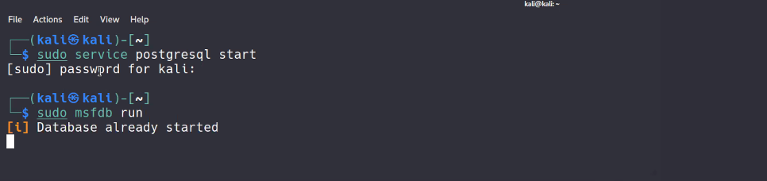

Expoilt to perform:

Search vsftp same as Project C

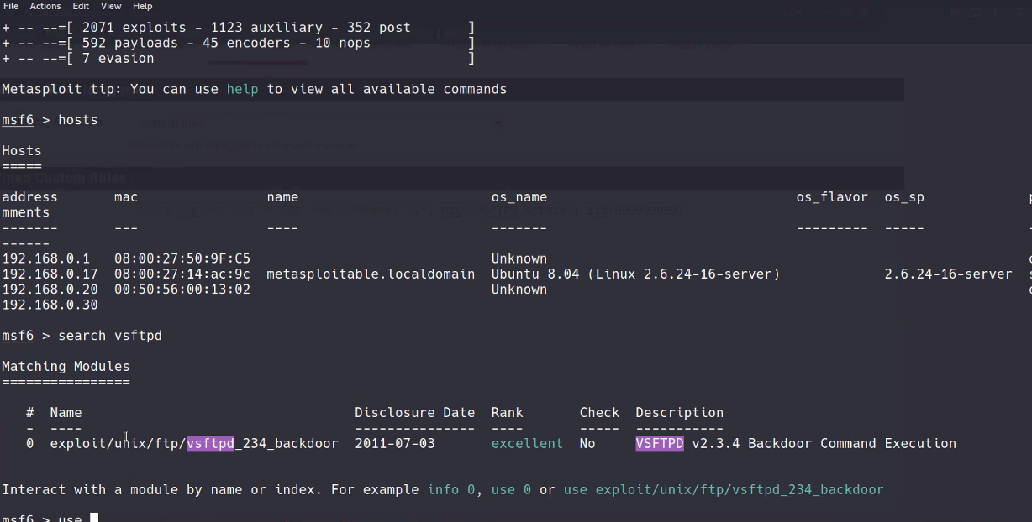

To run backdoor vsftpd on untrusted…..do not set rhosts just run exploit and set wirecapture at same time!!vsfback

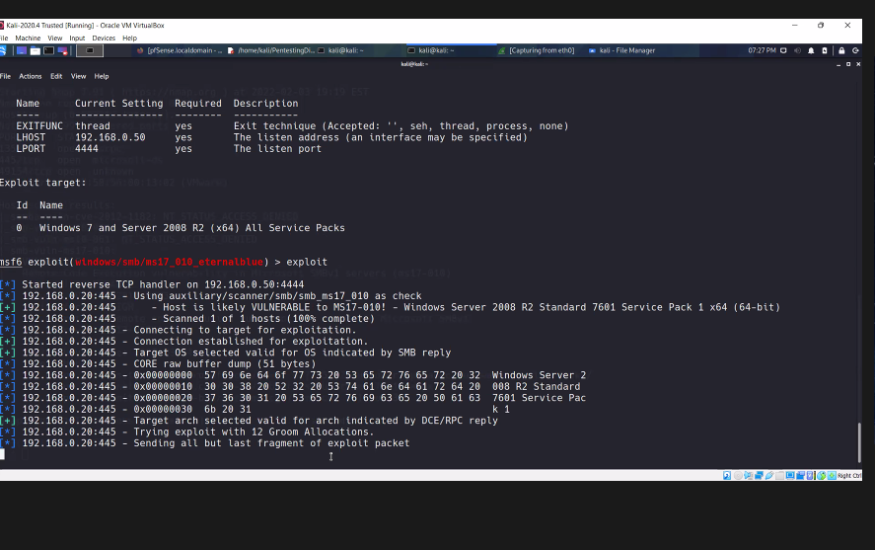

VIDEO ABOUT:

20 mins

28 MINUTES IN.

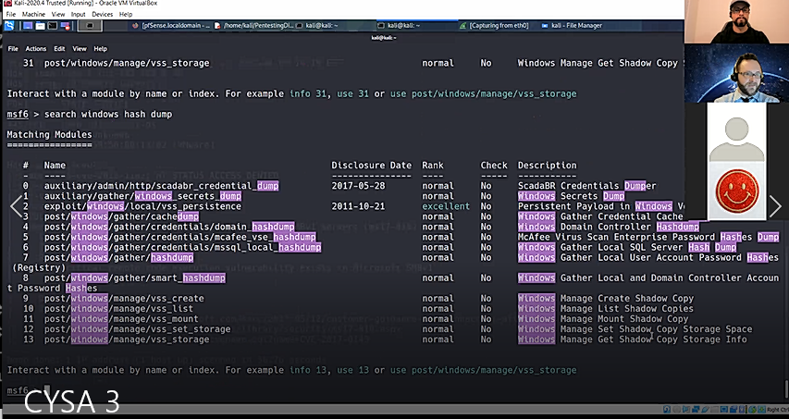

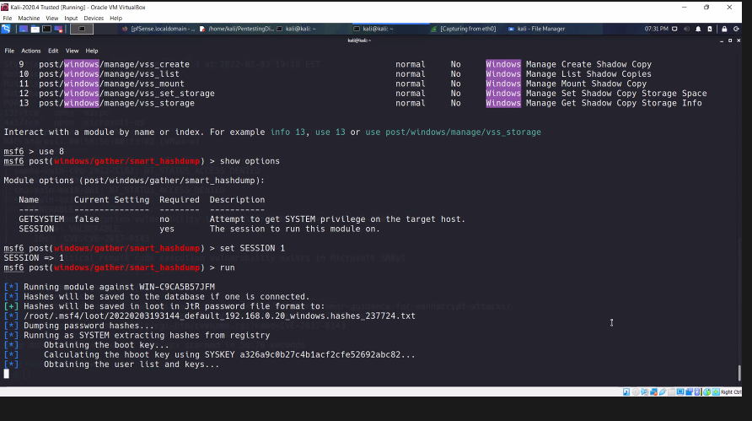

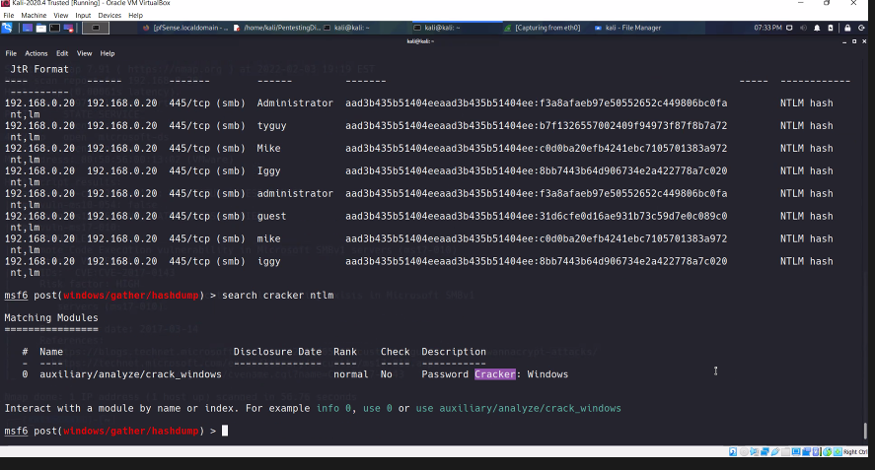

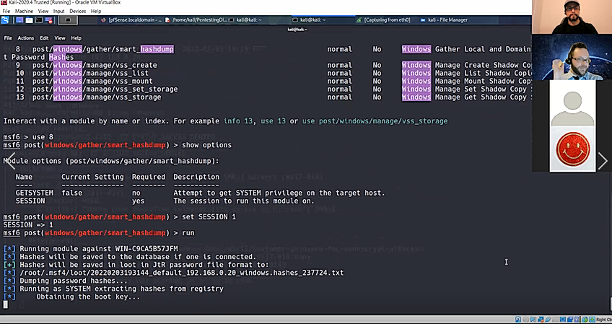

His session is on the .20 ip but yours was .17 that was open tcp ports. Easier 😊

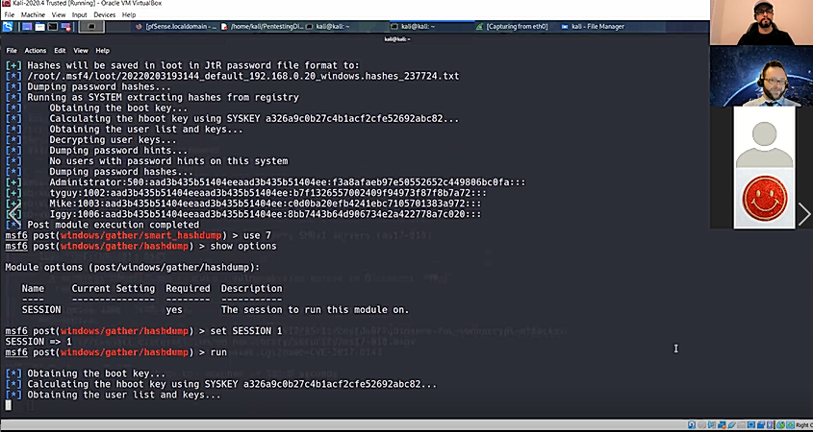

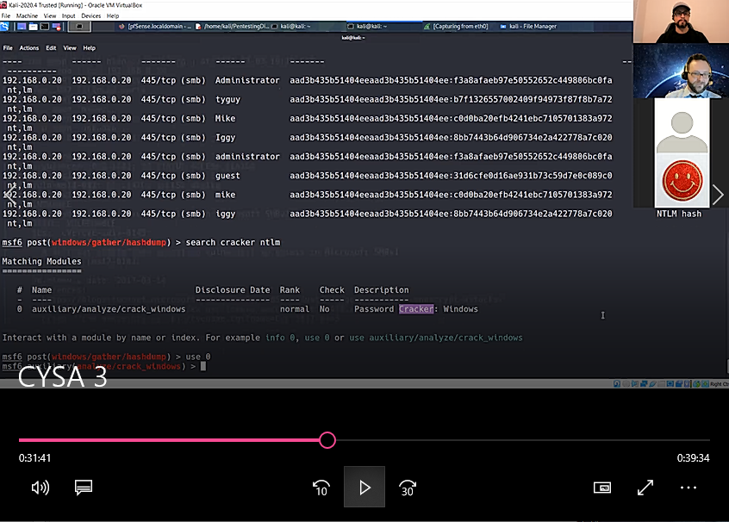

Do the nmap scan to pop up alerts on untrusted and DMZ (Webserver)

DO the SMB exploit on both

Do the VSFTPD exploit on both

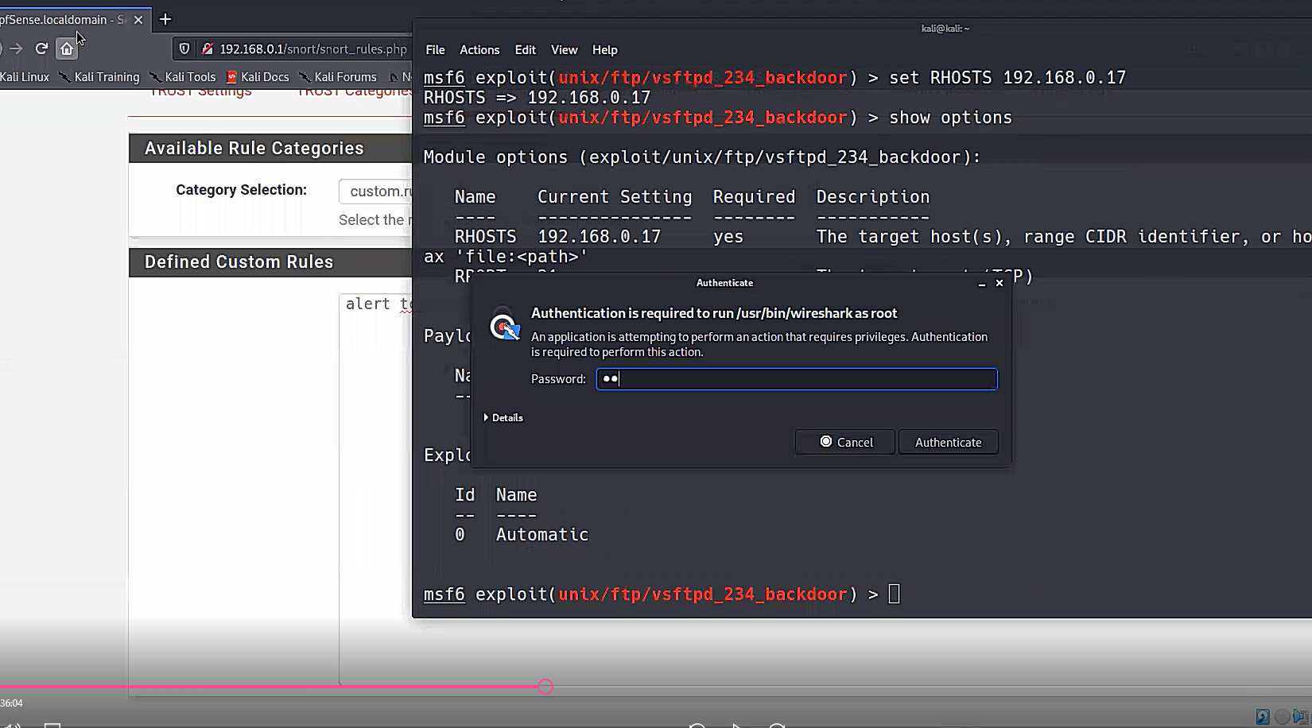

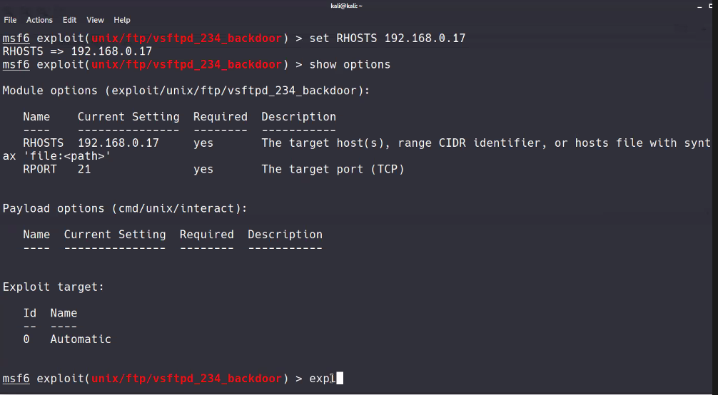

Run WIRESHARK at the same time